The Vinton Messenger, Debbie Adams
March 4, 2020

2019 5th Annual Tweed Ride Showcases Historic Vinton Landmarks

This year (2019) RIDE Solutions and the Roanoke Valley Preservation Foundation (RVPF) selected historic Vinton as the destination for their annual Tweed Ride bicycle tour.

On a chilly November 9, 2019, about 20 hardy bicyclists gathered at the Vinton History Museum. Some were veterans of previous RIDE Solutions bicycle tour events; for others this was their first venture.
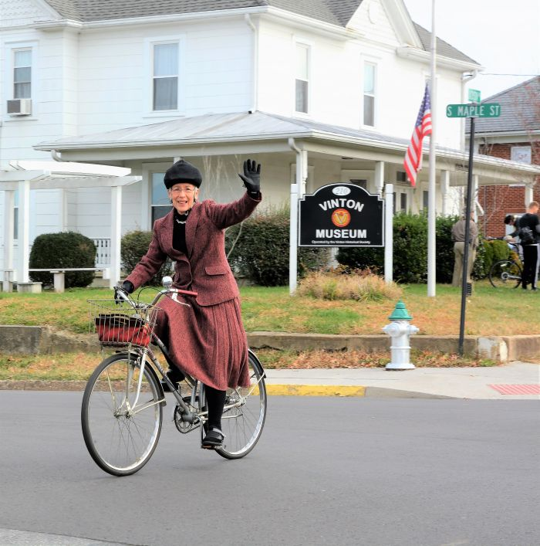
Barbara Duerk featured her tweed apparel for the 2019 Tweed Ride and her Western Flyer bicycle which she has been riding since high school. (photo by Debbie Adams)

The tour was led by Jeremy Holmes, director of RIDE Solutions, a program of the Roanoke Valley-Alleghany Regional Commission (RVARC) with Rachel Ruhlen, Transportation Planner with RVARC as sweeper at the back of the ride.

In promoting the event, Holmes described it as “a genteel bike tour, meandering from downtown Vinton, along the Wolf Creek Greenway, through the countryside and back, exploring some of Vinton’s historical sites and scenic views,” via a “step back in transportation history.”

Bicyclists were encouraged, but not required, to don some form of tweed apparel.

Barbara Duerk, not only featured an authentic tweed outfit, she was riding a Western Flyer bicycle, which she has owned since her high school years, purchased from Western Auto. Tom Copenhaver was riding a vintage 35-pound bicycle with none of the fancy gearing featured in more modern bikes.

Bicyclists gathered at the Vinton History Museum, which was hosting the event, for registration, doughnuts courtesy of Rosie’s Gaming Emporium, a group photo by Bella Muse photography, and some quick facts about the museum from Vinton Historical Society President Randy Layman and Executive Secretary Judy Cunningham.
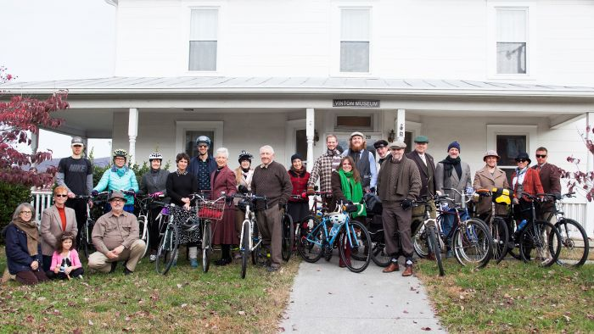The annual RIDE Solutions Tweed Ride started off from the Vinton History Museum on November 9. (photo courtesy of Marissa Yi, Bella Muse Photography)

The museum is housed in the historic Upson House on Jackson Avenue, built in 1906 by prominent Vinton businessman J.H. Upson and donated to the Town of Vinton by his daughter, Mary Upson Williams, in 1988 for “public and municipal purposes.”

The history museum opened in 1989 in partnership with the town and is now overflowing with over 4,000 catalogued treasures from Vinton’s past. The museum hosts over 1,000 visitors annually.
From the museum, the bicycle group continued the eight-mile journey with a swing past the Vinton Town Clock at the Municipal Building on Pollard Street. The clock was believed to have been installed in front of Rankin Jewelers in Roanoke as early as 1901, but eventually made its way in the early ’50s to Vinton. It was moved to the Municipal Building when it opened in 1983. Manufactured by Seth Thomas, the clock is built of cast iron.

The next stop on the Tweed tour was at the Roland E. Cook Lofts for an interpretive presentation by Alison Blanton of the Roanoke Valley Preservation Foundation, inc.
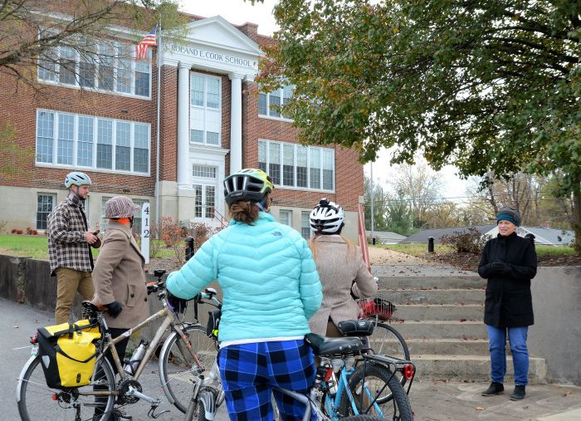The Roland E. Cook Lofts stop on the Tweed Ride. (photo by Debbie Adams)

Built in 1915, the Vinton school reflected the Progressive Era movement to consolidate one-room schoolhouses to improve education for white students in rural areas.
Designed in the Classical-Revival style by architect G.R. Ragan, the Vinton school showcased a full-height pedimented entrance portico supported by monumental columns.

In 1945, the school was renamed in honor of Roland E. Cook, its principal from 1897 to 1902 and Superintendent of Roanoke County Schools from 1906 to 1945.
Between 1962 and 1969 Roland E. Cook desegregated. Old School Partners renovated the school in 2016 as market-rate apartments, now fully occupied.

Up next was a brief stop at one of Vinton oldest homes, the Nicholas Vinyard house, located inconspicuously on Lauderdale Avenue.
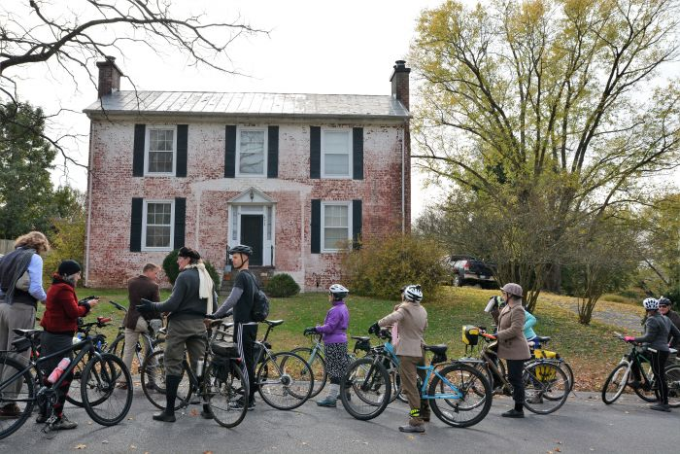Vinyard House on Lauerdale stop.

The house was built by a member of the Vinyard family, early Gish’s Mill residents. A classic brick “I’ house, this structure remains in very good condition as it has been occupied as a residence for many years. Various sources date the home from 1830 to the 1860s.

The brick used to build the house was made on the Vinyard farm by enslaved labor. The brick walls of the home are said to be one foot thick, with a plaster and stucco finish on the interior.

The original part of the house has two rooms on the first floor and two rooms on the second floor, with an additional small room off the second-floor landing. The house is flanked by two chimneys with the fireplace, interior doors, and hardware original to the house.

The home was included in a Civil War Homes Tour of Roanoke County in recent years. The description of the house at that time said that there was also evidence of a well in the backyard and a family cemetery just down the street.

The Tweed tour next headed down Hardy Road in the bike lane (said to be the first bike lane in the Valley back in 2003) to the Wolf Creek Greenway, possibly the most challenging leg of the tour with its crushed-stone trail.
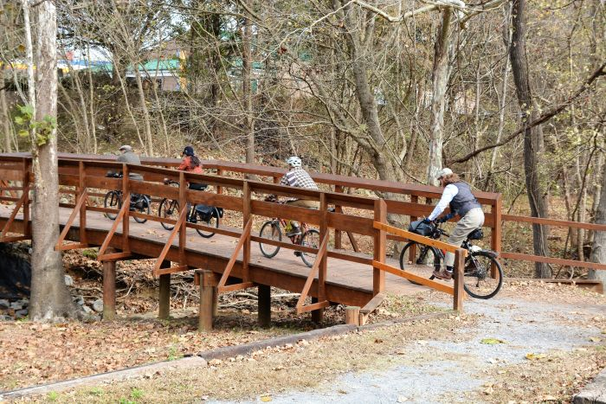Bicyclists experienced the challenges of the crushed stone trail on the Wolf Creek Greenway (photo by Debbie Adams).

One of the oldest sections of Roanoke Valley Greenway, the Wolf Creek Greenway celebrated its 20th anniversary in the spring of 2019, described by Holmes as a “hidden gem.”

Blanton and the RVPF hosted another interpretive stop at the Barfield House/Gross Farm on Mountain View Road, at what currently marks the end of the greenway in Vinton– with plans for extension.

RVPF thanks Debbie Adams and The Vinton Messenger for producing this excellent article
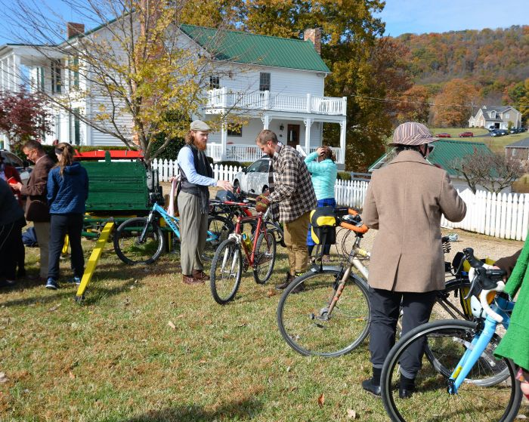Barfield House/Gross Farm on Mountain View Road was another stop on the Tweed Ride (photo by Debbie Adams).
This home was built in 1864 by Billy Muse, who years later gave it to his daughter Alice when she married Abe Fleming Gross. It was constructed from trees and stones on the original 800 acres of land. The house was listed as endangered in 2001.
The property was purchased by Lance Copperman, who kept the original character of the two-story farmhouse with the original pine floors, walls, and chimney bricks. The house was renamed for Vinton resident and educator Ken Barfield.
The home and its surrounding property are beloved by greenway users who stop to pet the farm animals or linger along the stream. New owners are Lisa and Josh Kossman.
The tour then proceeded down Mountain View to the Vinton War Memorial for a stop hosted by Vinton Community Programs and Facilities Director Chasity Barbour.
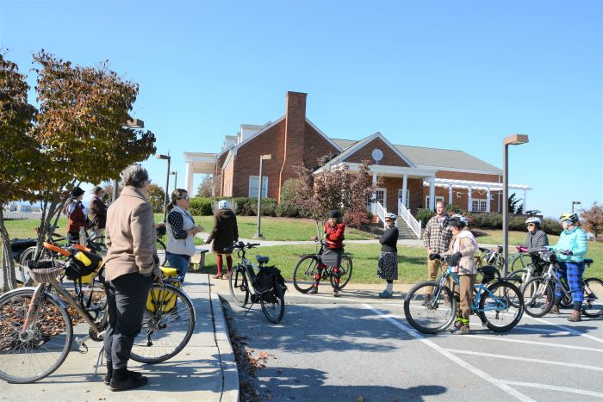Vinton Community Programs and Facilities Director welcomed the Tweed Ride to the historic Vinton War Memorial (photo by Debbie Adams).
The Vinton War Memorial was built to honor veterans of World War II and was officially dedicated in 1948. It has become known over time as the “Crown Jewel” of not only Vinton, but the Roanoke Valley, and a popular wedding and conference venue.
The Charles R. Hill Community Center was added to the complex in 1967. The War Memorial was renovated in 2007 with the stately High Ground Monument added in 2011, and the LOVE sign installed on the front lawn in 2018.
Holmes thanked those who participated in the 2019 Tweed Ride which he described as “one of the most diverse Tweed Rides yet for the infrastructure and roadways encountered.”
One goal of RIDE Solutions is to encourage the use of bicycles for transportation. Events such as the Tweed Ride make bicycle riders aware of alternate routes and less-traveled back roads.
The final stop of the tour was at Twin Creeks Brewing Company in downtown Vinton for relaxation, fellowship, and rehashing the challenging aspects of Tweed Ride 2019.
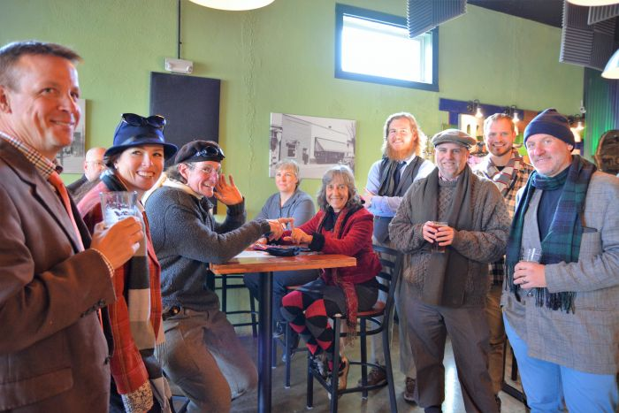The final stop on the 2019 Tweed Ride through Vinton was at Twin Creeks Brewing Company (photo by Debbie Adams).

https://ridesolutions.org/event/2019-tweed-ride/

